Bahria University,

Karachi Campus



COURSE: CSC-113 COMPUTER PROGRAMMING

TERM: FALL 2019, CLASS: BSE- 1 (B)

Submitted By:

M MUAZ SHAHZAD 02-131202-081

(Name) (Reg. No.)

Submitted To:

Engr. Adnan ur rehman/ Engr. Ramsha Mashood

Signed Remarks: Score:

INDEX

|  |  |  |  |  |
| --- | --- | --- | --- | --- |
| SNO | DATE | LAB NO | LAB OBJECTIVE | SIGN |
| 01 | 10-Nov-2020 | 08 | While Loop |  |
|  |  |  |  |  |
|  |  |  |  |  |
|  |  |  |  |  |
|  |  |  |  |  |
|  |  |  |  |  |
|  |  |  |  |  |
|  |  |  |  |  |
|  |  |  |  |  |
|  |  |  |  |  |
|  |  |  |  |  |
|  |  |  |  |  |
|  |  |  |  |  |
|  |  |  |  |  |
| SNO | DATE | LAB NO | LAB OBJECTIVE | SIGN |
|  |  |  |  |  |
|  |  |  |  |  |
|  |  |  |  |  |
|  |  |  |  |  |
|  |  |  |  |  |
|  |  |  |  |  |
|  |  |  |  |  |
|  |  |  |  |  |
|  |  |  |  |  |
|  |  |  |  |  |
|  |  |  |  |  |
|  |  |  |  |  |
|  |  |  |  |  |
|  |  |  |  |  |
|  |  |  |  |  |

Bahria University,

Karachi Campus



LAB EXPERIMENT NO.

**08**

LIST OF TASKS

|  |  |
| --- | --- |
| TASK NO | OBJECTIVE |
| 01 | Fibonacci series ( 0,1,1,2,3,5,8…) for and while loop |
| 02 | Repeatedly print the value of the variable x Value, decreasing it by 0.5 each time, as long as x Value remains positive. (while loop) |
| 03 | Print the square roots of the first 25 odd positive integers. (while loop) |
|  |  |
|  |  |
|  |  |
|  |  |
|  |  |
|  |  |
|  |  |
|  |  |
|  |  |
|  |  |
|  |  |
|  |  |

Submitted On:

11/11/2020

(Date: DD/MM/YY)

**Task No. 1: Fibonacci series ( 0,1,1,2,3,5,8…) for and while loop**

**Solution:**namespace Fibonnaci_series

{

class Program

{

static void Main(string[] args)

{

int j = 20;

int k = 0;

int l = 1;

int m = 0;

int i=0;

Console.WriteLine("FIBONNACI SERIES");

Console.WriteLine();

while (m <= j)

{

Console.WriteLine(i);

i = k + l;

l = k;

k = i;

m++;

}

Console.ReadLine();

}

}

}

**Output:**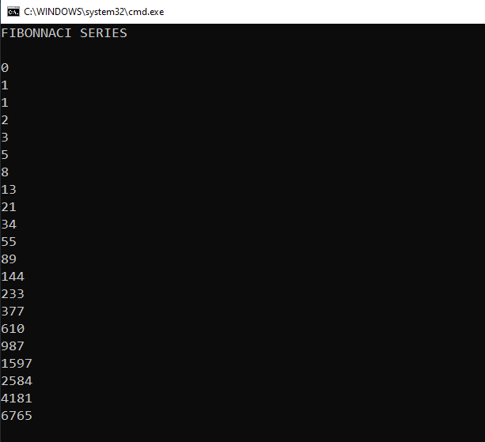

**Task No. 2: Repeatedly print the value of the variable x Value, decreasing it by 0.5 each time, as long as x Value remains positive. (while loop)**

**Solution:**namespace X_VALUE_while

{

class Program

{

static void Main(string[] args)

{

Console.WriteLine("Value of X Variable");

Console.WriteLine();

double f = 10;

while(f > 0)

{

f = f - 0.5;

Console.WriteLine("{0}", f);

}

}

}

}

**Output: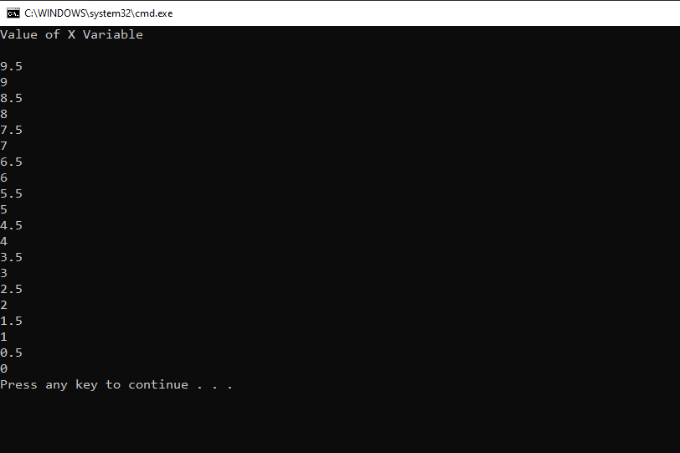 Task No. 3: Print the square roots of the first 25 odd positive integers. (while loop)**

**Solution:**namespace Odd_num_while

{

class Program

{

static void Main(string[] args)

{

Console.WriteLine("=====================");

Console.WriteLine("First 25 Odd Integers");

Console.WriteLine("=====================");

Console.WriteLine();

double f = -1;

while(f < 49 )

{

f = f + 2;

Console.WriteLine("Square Root Of {0} is {1}", f, Math.Sqrt(f));

}

Console.ReadLine();

}

}

}

**Output:**